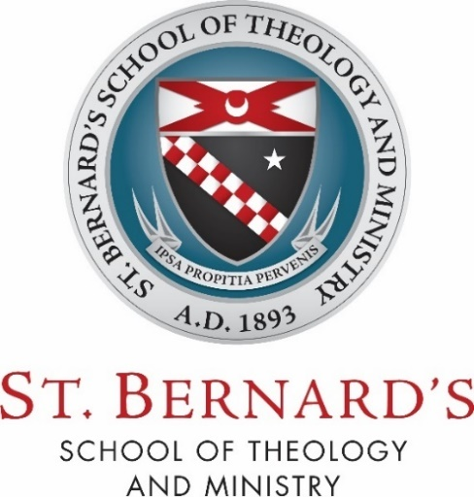

D203 – Pastoral Field Education

Self-Evaluation Rubric

Kindly answer the following questions relative to each learning outcome:

How were the learning outcomes for this course fulfilled in, by, or through this ministry? Are there any differences between the expectations expressed in the Learning Agreement and the actual fulfillment of these outcomes? If so, what are they and what did you learn from them?

- Knowledge Attained:
  - demonstrate an understanding of the role and function of this ministry within the Body of Christ

  - articulate a knowledge of the theological dimensions of this ministry

  - provide evidence of careful consideration and discernment in relation to this ministry’s contribution to one’s human, spiritual, intellectual, and pastoral growth.

- Skills Attained:
  - apply what one has learned in the areas of spirituality and ministry, faith and theology

  - hone the communication and relational skills appropriate to a person engaged in active ministry

  - exercise the pastoral skills needed to fulfill this ministry, such as collaboration, gift discernment, change and conflict management, leadership and administration, and/or counseling

  - practice and refine the virtues of Christian discipleship, especially those which pertain most directly to ministers in the Church, such as “honesty, humility, compassion, initiative, courage, vision, energy, hospitality, and Christian joy” (Co-Workers in the Vineyard, 37).

- Attitudes Attained:
  - develop the habit of self-reflection regarding one’s, gifts, personality, talents, strengths, weaknesses, and limitations

  - cultivate a disposition which sees this ministry as an outward expression of one’s inner spiritual life; in particular, a life shaped by prayer and the liturgy,

  - grow in appreciation for the many and varied ministries that all work together to build up the one Body of Christ.

