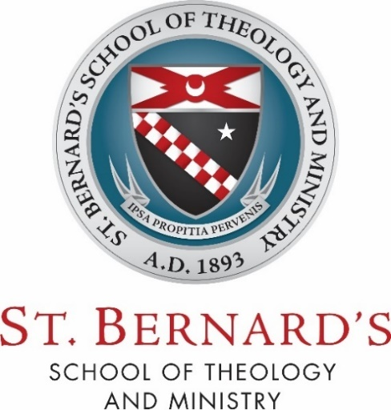

D203 – Pastoral Field Education

Supervisor Evaluative Report

Reports are required after every one credit (50 hours) of Pastoral Field Education Placement. They should be submitted to the Advisor and the student after the completion of each credit; all reports should be submitted to the Field Education Coordinator upon completion of the total placement.

Student Name:

Supervisor Name: Supervisor Email:
Supervisor Title:

Field Education Placement Organization:

Date:

Has the student attended and participated in the placement as outlined in the learning agreement?

Kindly answer the following questions relative to each learning outcome:

- Knowledge Attained:
  - Is there evidence of this student’s careful consideration and discernment in relation to this ministry’s contribution to one’s human, spiritual, intellectual, and pastoral growth?

- Skills Attained:
  - Has the student applied what they have learned in the areas of spirituality and ministry, faith and theology?

  - Has the student exhibited the communication and relational skills appropriate to a person engaged in active ministry?

  - Has the student exercised the pastoral skills needed to fulfill this ministry, such as collaboration, gift discernment, change and conflict management, leadership and administration, and/or counseling?

  - Has the student practiced and refined the virtues of Christian discipleship, especially those which pertain most directly to ministers in the Church, such as “honesty, humility, compassion, initiative, courage, vision, energy, hospitality, and Christian joy” (Co-Workers in the Vineyard, 37).

- Attitudes Attained:
  - Has the student exhibited the habit of self-reflection regarding one’s, gifts, personality, talents, strengths, weaknesses, and limitations?

Supervisor’s Signature: Date:

